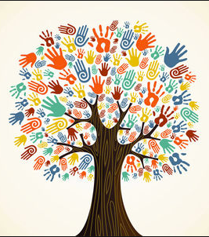 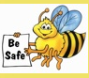

**Overview**

This unit will review our PVES Great Expectation: Be Respectful. Over the next two months our focus will be centered around conversations and activities highlighting Peace, Diversity, and the concepts outlined in the Energy Bus guide.

**Book Guide for Energy Bus: No Bullies Allowed**

Energy Bus pages 26-32

**Other *Recommended Books for this Unit:***

*Let’s Talk About Race

The Colors of Us

*I am America

Peace Begins with You

*These books were previously provided by the committee and should already be in your classroom libraries.

**January & February**

***The Character Education and Diversity Committee Newsletter***

**Unit 3 Resources:**

**Our Pledge**

**I promise to do my best this week. I pledge to be kind, safe, respectful and responsible.**

**This Year’s Theme: Character Counts**

**This Month’s Unit:**

**Be Respectful:**

**Peace**

**&**

**Diversity**

**Calendar of**

**Upcoming Events**

***Classroom Activities:***

***“The Energy Bus”***

Please read the next section of the Energy Bus with your class, focusing on Goal Setting.

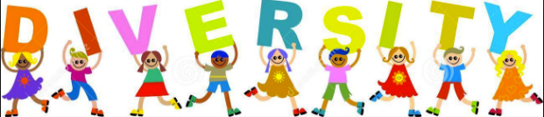

***Essential Questions for Discussion:***

* ***What does diversity mean to me?***
* ***How can we celebrate the diversity of our class? School?***
* ***How can we show respect for the unique qualities of others?***

***“All About Me: Diversity & Peace Hands”***



Students will trace their hand and forearm onto the color paper of their choice and then draw or write things that represent their life: culture, beliefs, traditions, etc. Glue the hands either to the poster paper (which can be provided upon request) or hang outside of your classroom as you wish. Students will be able to see how diverse our school is and what ultimately makes PV the wonderful place that it is!

Grades K-1: Hands about Peace: “What peace means to me”

Grades 2-4: Hands about Diversity: “All About Me”

***Current Members:***

*If you have any questions or comments, please feel free to contact any of the current members of the Character Education and Diversity Committee.*

Kindergarten: Kerri Burdett, Lauren Soprano, Abby Foor-Liso

First Grade: Leesa Hernandez

Second Grade: Kristan McCarty, Nanette Romanello

Third Grade: Chrissy Phillips, Jenn Bruno, Shannon Tarkington

Fourth Grade: Sue Boyd, Katie O’Dell

Psychologist: Sue O’Connell, Mary Trento

Support Services: Michele Lussier, Dorothy France

Specialist: Maddy Calhoun

***Ongoing Initiatives:***

-Regularly referencing the PVES Great Expectations (being kind, safe, respectful and responsible).

-Earning leaves on the Tree of Great Expectations for ongoing excellent behavior over time.

-Referencing the Great Expectations in everyday conversations.

-Determining if problems are BIG or small based on how they make you feel, and solving them accordingly.

-Practicing “upstanding behavior.”

-Identifying and reporting ongoing “bullying behavior.”

-Recycling bottles, cans, clean plastic and paper in the appropriate receptacles.

***Great Expectations Follow-up”***

Do your students know what the Great Expectations are? Could they name them? Are they able to provide examples of each? As a class, come up with (or provide) a definition for each of the Great Expectations. During your class read alouds, ask students if the characters they come across are demonstrating one or more of the Great Expectations, or if they are doing the opposite. Ask them to explain which G.E. is being followed or broken, and how they know, using text-based examples. (For example: Georgia Peachpit from Mrs. McBloom Clan Up Your Classroom was being *responsible* when she made a plan for all of the Up Yonder community to pick up one piece of trash to throw away or donate in order for Mrs. McBloom’s classroom to get cleaned out. Her idea inspired the community to be responsible too!)